Brian Dunn
Rahil Patel

1)
Candidate classes: Rolling Wrecks Corp, staff, inventory, RWC site, repair shop, driver, appointment, rental paperwork, customer, rental car, own car, repair bill, payment

Candidate responsibilities: checks the available inventory, looking for the closest car, driver is scheduled to deliver, driver presents the rental paperwork, presents it to the customer, repair shop adds the charge, notifies RWC that the car has been returned

The repair bill and associated responsibilities are not going to be used in the application because they don’t change the price of the car rental and quite simply don’t matter to the WRC end of things. (We took care of the price in the paperwork since RWC will be setting the price.)

2.)

Rolling Wrecks Corp
add RWC site | RWC site

staff
find matching car  schedule driver | Rolling Wrecks Corp  RWC site  repair shop

inventory
add/remove rental car | RWC site  rental car

RWC site
set/get location  add/remove driver  add/remove inventory | Rolling Wrecks Corp  driver  inventory  staff

repair shop
set/get location  add/remove customer  add/remove appointment  notify returned rental | RWC site  staff  customer  appointment

driver
add/remove workday  add/remove delivery  add/remove pickup | RWC site  rental paperwork

appointment
set/get date | repair shop  staff

rental paperwork
set/get price  print paperwork | RWC site  repair shop

customer
set/get name  add customer car | repair shop  customer car

rental car
set/get model  set/get make  is available? | RWC site  driver

customer car
set/get model  set/get make  is returned? | customer  staff

payment
add rentalprice  calc weeklypayment  disp weeklypayment | RWC site  repair shop

3)

RWC

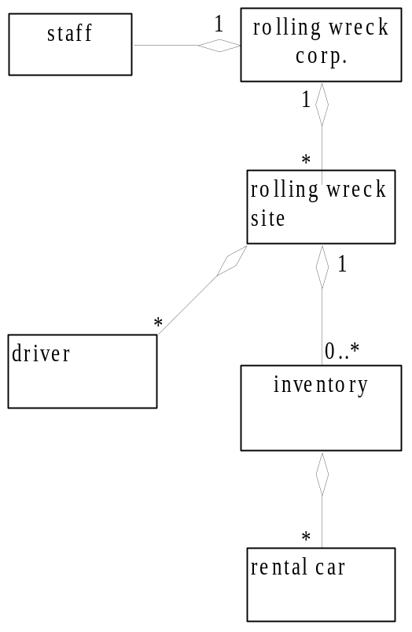

Repair shop

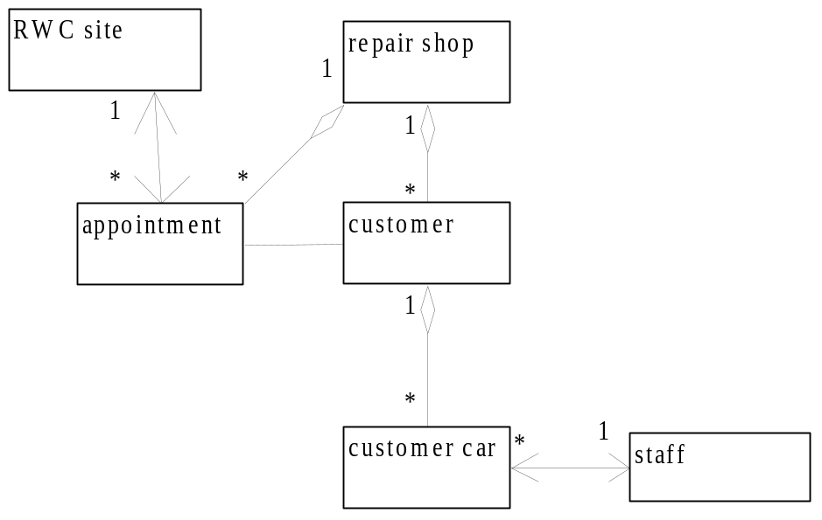

Transaction

